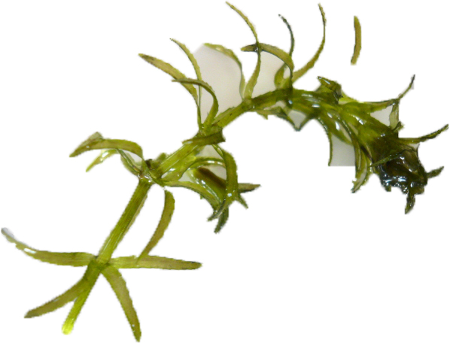
Maine’s lakes & streams are being invaded!

E a r l y D e t e c t i o n
is o u r b e s t d e f e n s e

Learn how to spot a suspicious plant when you are out on the water.
Gain the skills you need to form your own local early detection effort.

Maine Volunteer Lake Monitoring Program

INVASIVE PLANT PATROL WORKSHOP

Hosted by (list all local host groups here)
On (day), (date), from (start time) to (end time)
At (location, with brief directions to location if needed)

The workshop is free. All are welcome to attend!
Please see the back of this flyer for a list of things to bring.

IMPORTANT: Pre-registration is required for all workshops. Please contact the Maine Volunteer Lake Monitoring Program at vlmp@mainevlmp.org or (207) 783-7733 to register, or for more information. (Sponsor contact info may be added here for taking registrations if desired.)

Maine’s lakes, rivers and streams are increasingly threatened by non-native invasive plants. Once established in a lake, stream or pond, early detection of an invasive aquatic plant provides the best hope of eradicating the invader. Trained volunteers play an extremely important role in this effort. The work is interesting, rewarding and fun!

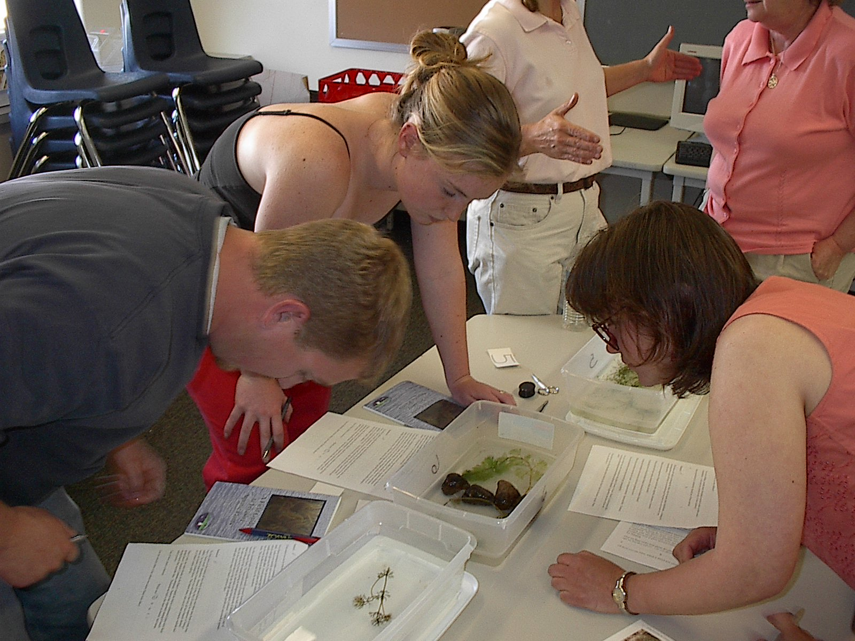
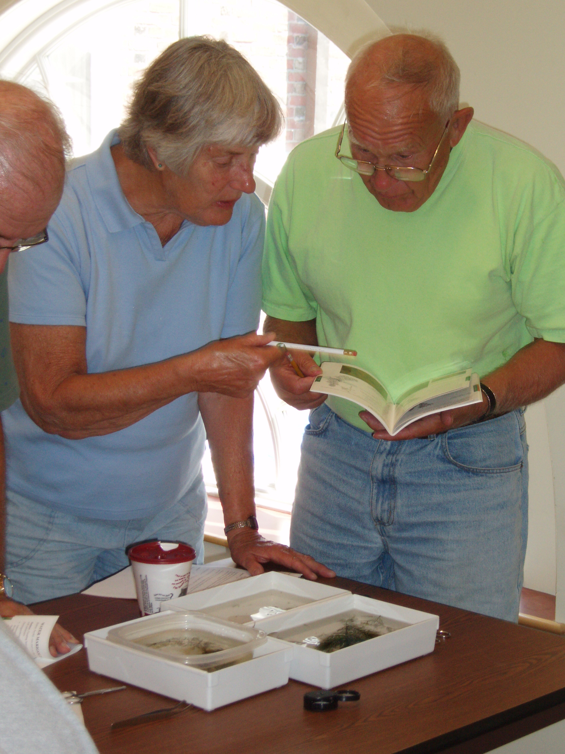
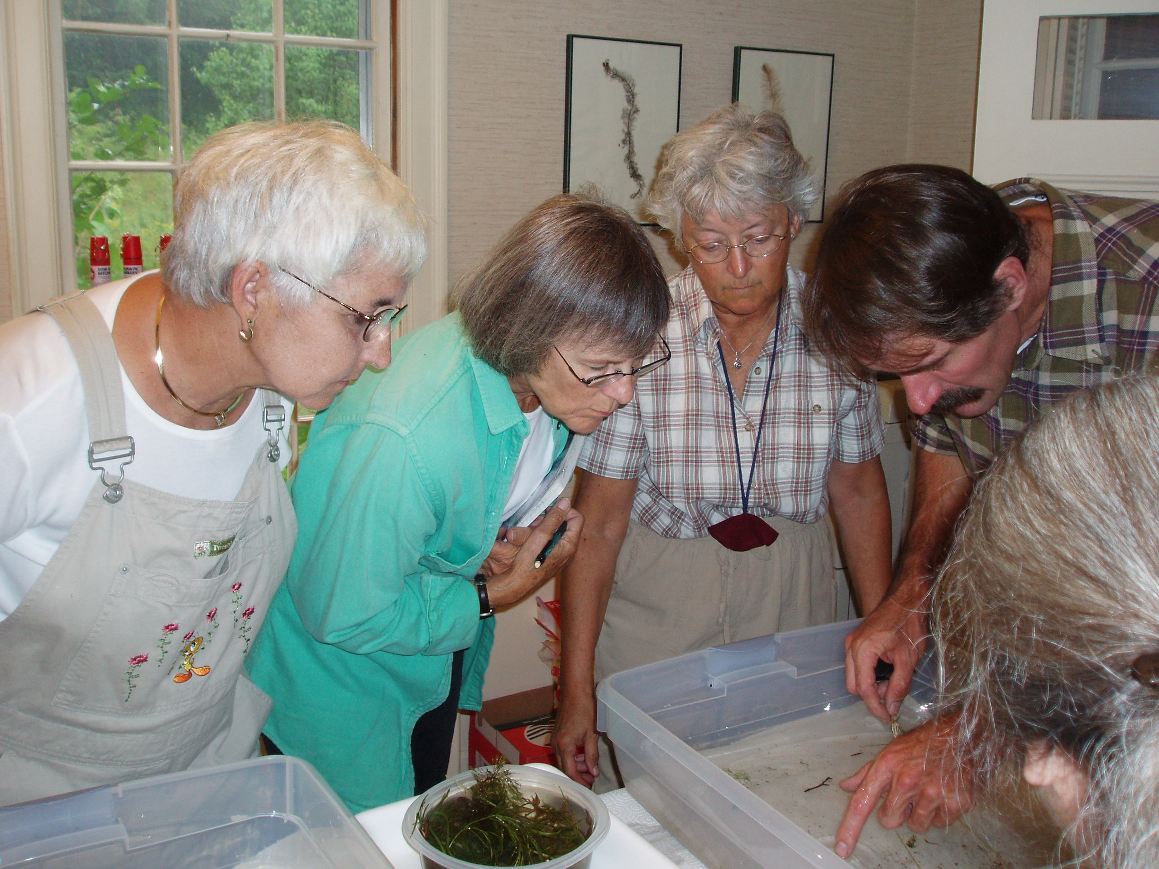
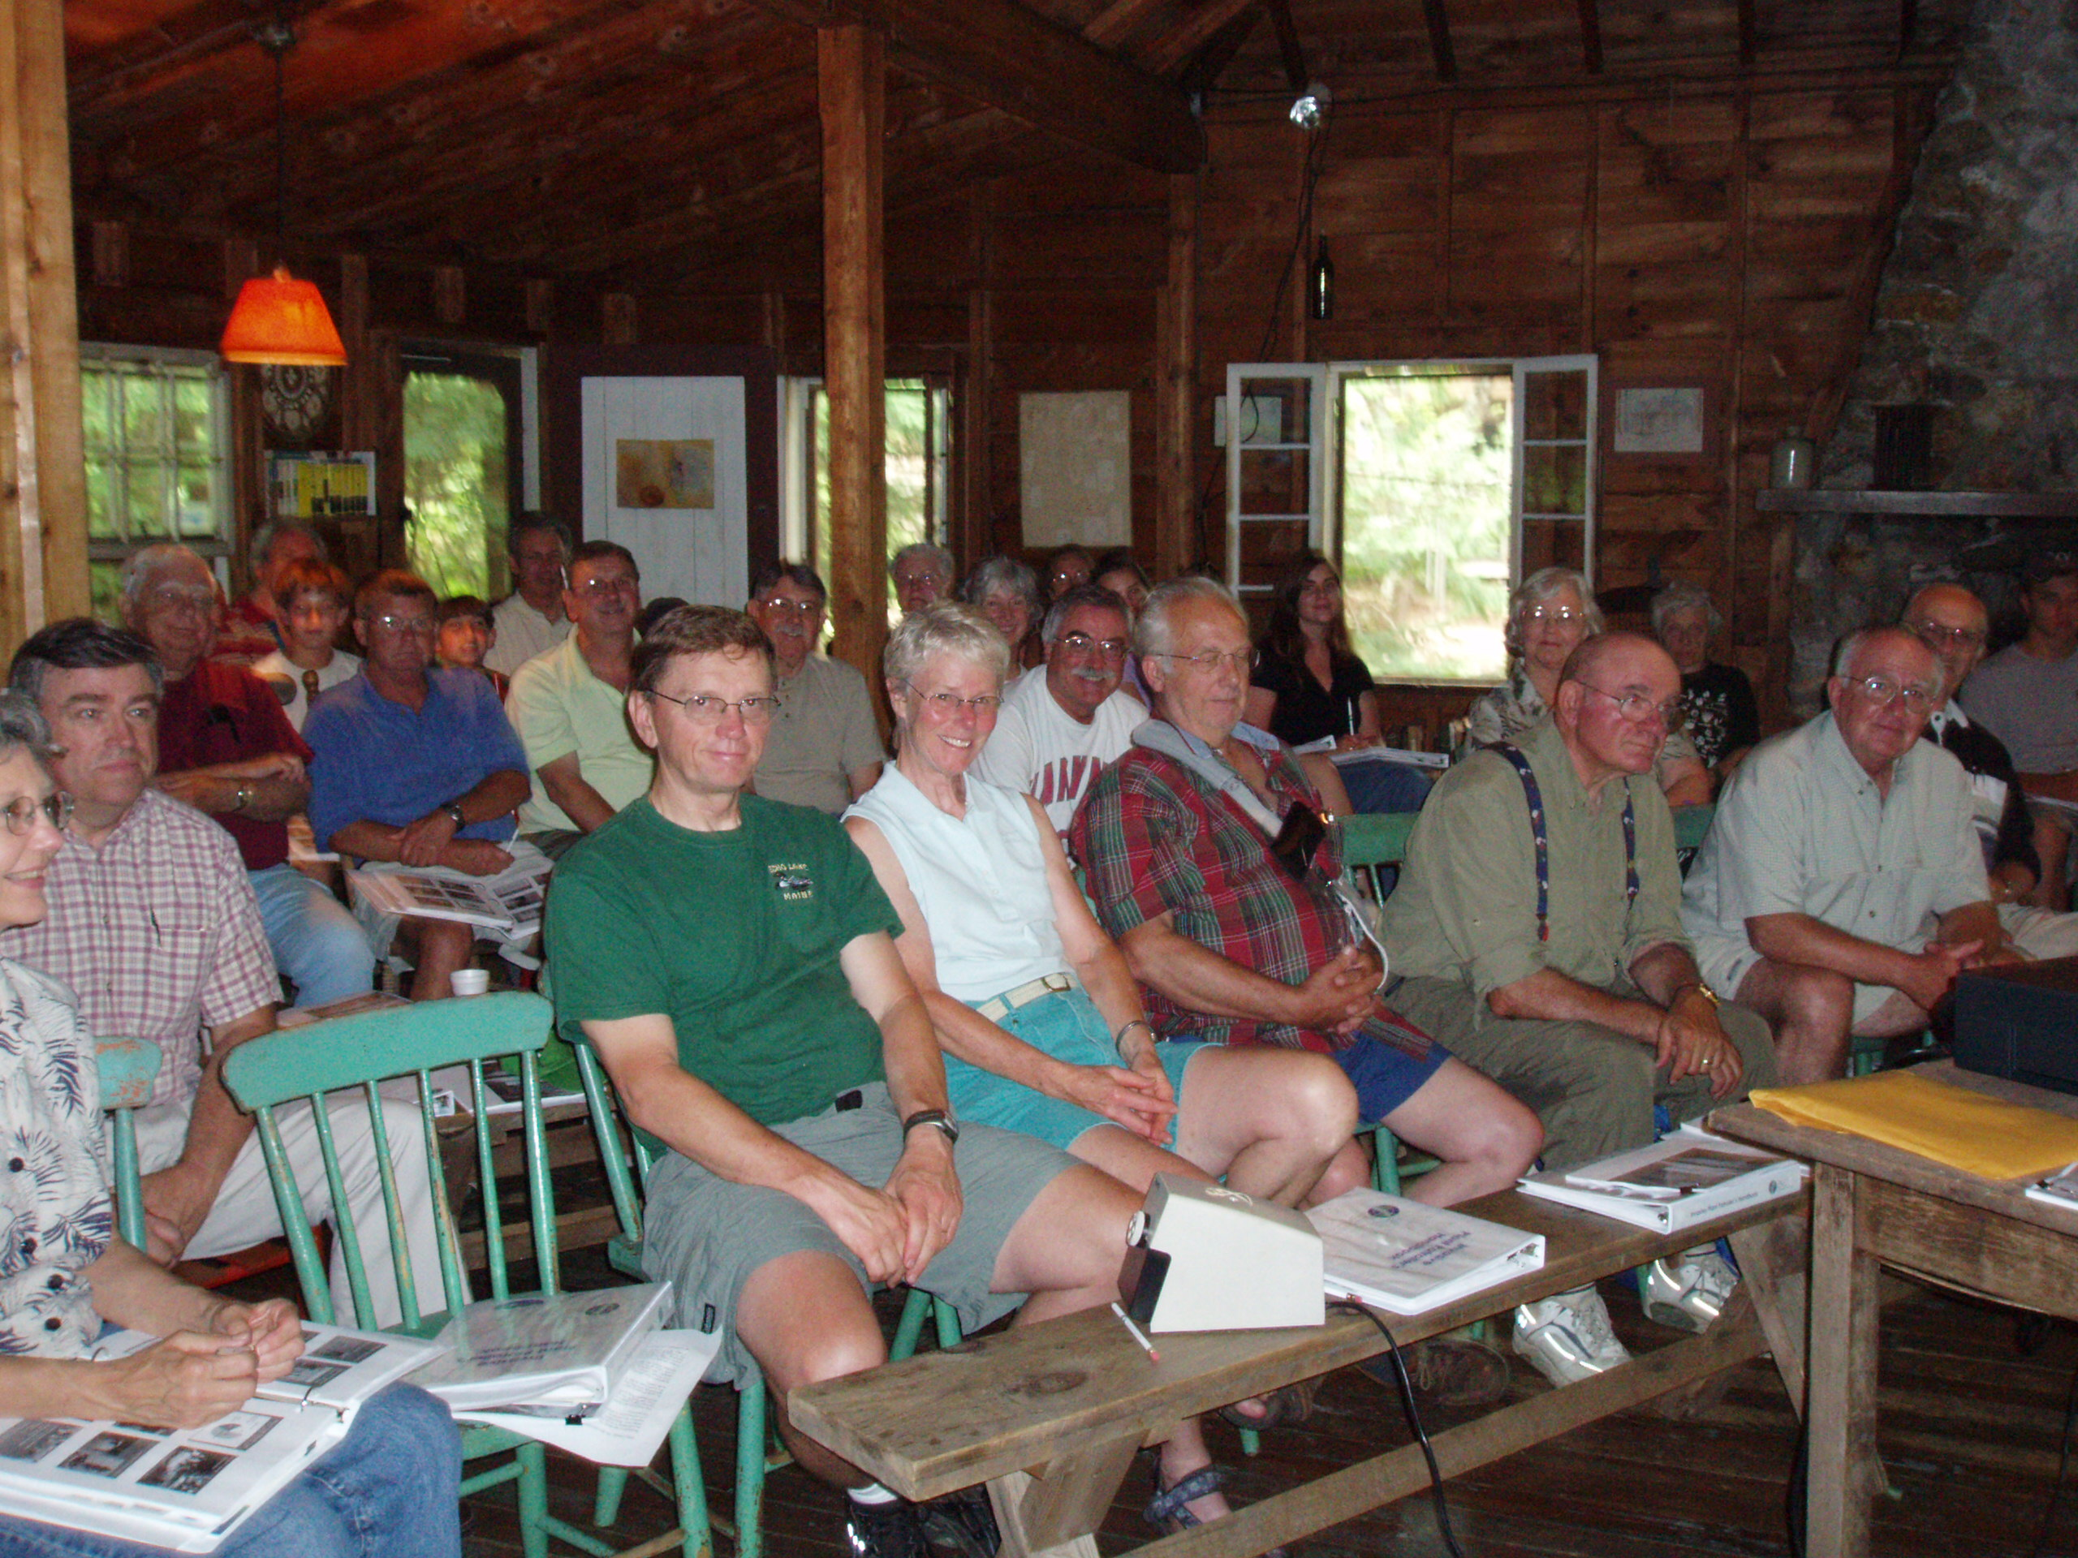
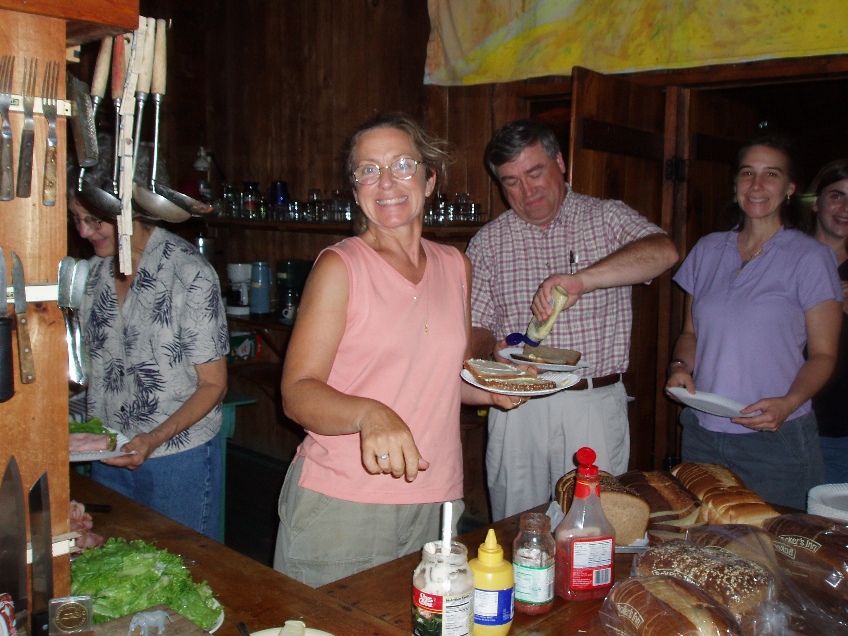

The workshop will provide . . .
- An overview and update of the threat of invasive aquatic plants in Maine
- Introduction to “Maine’s Eleven Most Unwanted” invasive aquatic plants and other invaders
- An opportunity to practice plant identification with live plants
- How to conduct an invasive aquatic plant screening survey & form your own survey team
- The IPP Handbook, a three-ring binder full of useful information, including a free copy of the Maine Field Guide to Invasive Aquatic Plants

Invasive Plant Patrol workshops are made possible with support from ~
Maine Volunteer Lake Monitoring Program,
Maine Department of Environmental Protection,
Boater participation in Maine’s Lake and River Protection Sticker Program,
Lake Auburn Watershed Protection Commission, Maine Milfoil Initiative,
The Ram Island Conservation Fund of the Maine Community Foundation,
Portland Water District, Roy A. Hunt Foundation,
& donations from Individuals, Workshop Hosts,
Lake & watershed Associations, and Businesses

hosts for this workshop include:
List the workshop hosts for your workshop here

